1. Digital output:

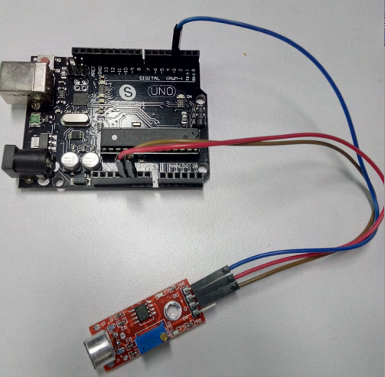

int Led = 13 ;// define LED Interface

int buttonpin = 3 ; // define D0 Sensor Interface

int val ;// define numeric variables val

void setup ()

{

pinMode (Led, OUTPUT) ;// define LED as output interface

pinMode (buttonpin, INPUT) ;// output interface D0 is defined sensor

}

void loop ()

{

val = digitalRead (buttonpin) ;// digital interface will be assigned a value of 3 to read val

if (val == HIGH) // When the sound detection module detects a signal, LED flashes

{

digitalWrite (Led, HIGH);

}

else

{

digitalWrite (Led, LOW);

}

}

2.Analog outputs:

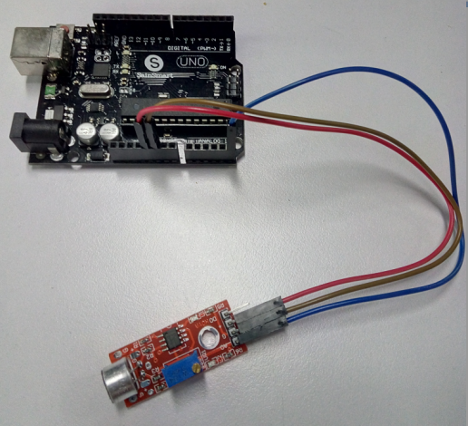

int sensorPin = A5; // select the input pin for the potentiometer

int ledPin = 13; // select the pin for the LED

int sensorValue = 0; // variable to store the value coming from the sensor

void setup () {

pinMode (ledPin, OUTPUT);

Serial.begin (9600);

}

void loop () {

sensorValue = analogRead (sensorPin);

digitalWrite (ledPin, HIGH);

delay (sensorValue);

digitalWrite (ledPin, LOW);

delay (sensorValue);

Serial.println (sensorValue, DEC);

}